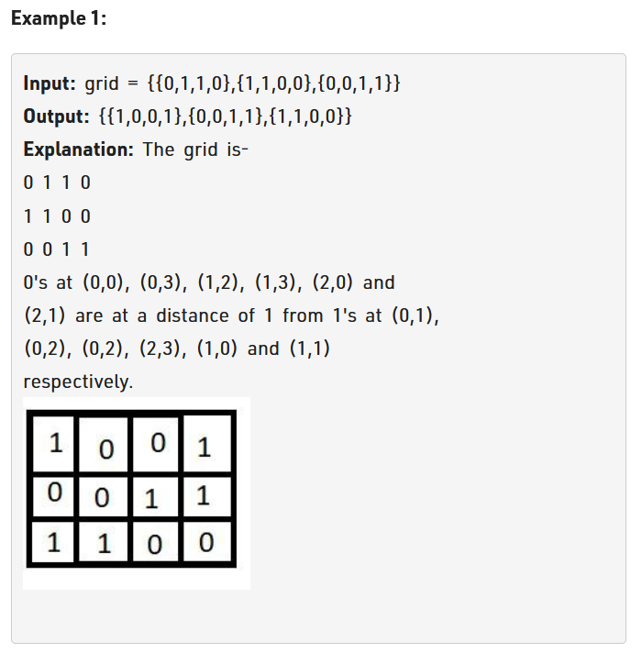

Logic:

See here for cell containing matrix nearest 1 will be itself and hence for cell having value 1 will be 0 in answer.

See resultant distance.

See here we will take all the 1 and make them in all the 4 direction move 1 step and check which zero they reach and hence value of that 0 will be 1 for the 1st step. Now after this changed to 1 we will again take step in all direction for whose value is 1 so the 0 not reached will now have value of 2 as 2nd step.

See we will reach next set of 0 in next step.

See bfs we use it as it allows 1 to take a single step all at the same time. While dfs would have allowed like taken a single 1 and made it transverse the whole matrix.

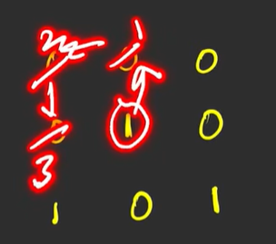

This would have been dfs.

See take a new matrix and mark everyone as 0 over there.

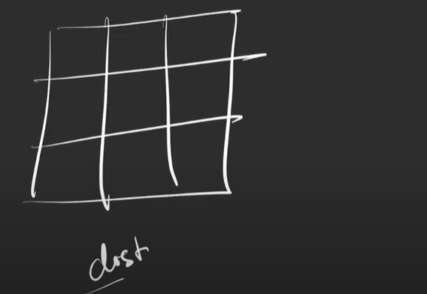

1 more matrix to store distance.

See where is 1 in the above matrix is the starting point of out bfs. This can be called a multisource bfs.

Now we will also need queue.

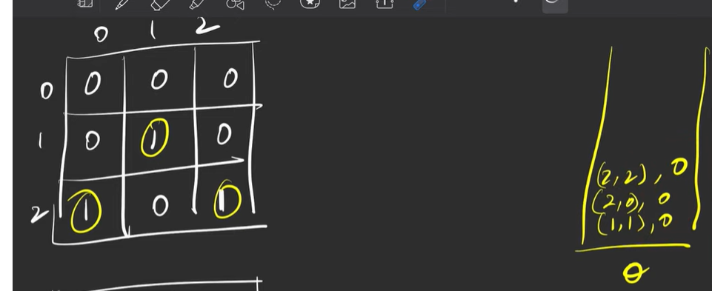

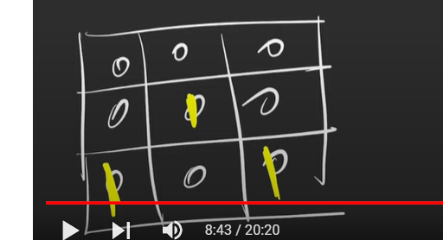

Also mark them as visited.

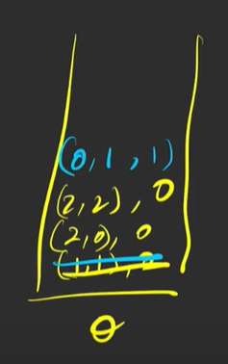

See from the queue above we will take (1,1),0 and will see that it goes all the four direction. Also visited array will show that its value changes from 0 to 1 for (01,0) also take this for the queue.

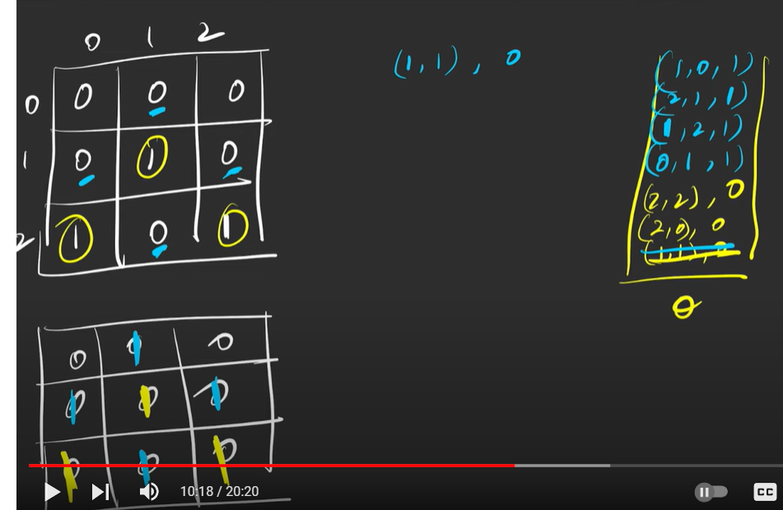

See 1,1 can visit 4 direction (0,1),(1,0), (1,2), (2,1). Also, whichever visited here mark them as 1.

Now go for (2,0),0 do the same procedure.

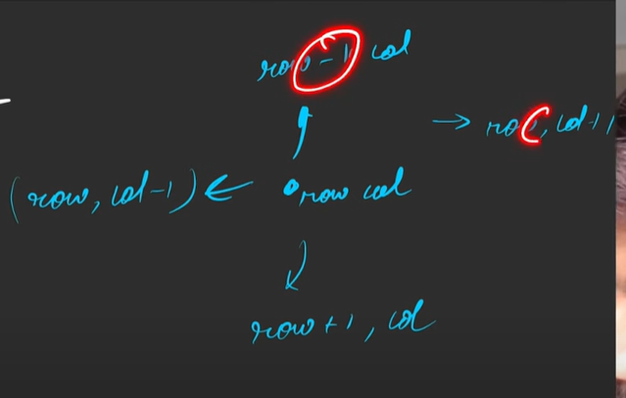

For the all direction.

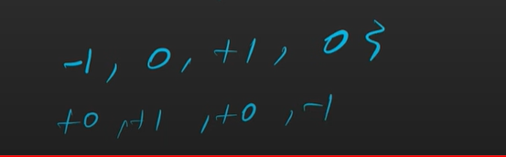

See for this we can take an array. We can take 2 array and then we can run loop for the above all the direction.

Code:

<https://takeuforward.org/graph/distance-of-nearest-cell-having-1/>